1. What is software process model? Difference between cohesion and coupling in programming.
Ans :
Software process model is a set of related activities that lead to development of software. It represent the order in which the activities of software development will be undertaken. Different types of software models are,
- Waterfall Model: This is the simplest software development life cycle model which states that the phases are organized in linear order. In this model, until one phase is not finished another will not start.

- Prototyping Model: In traditional waterfall model the intermediate changes in the users requirement cannot be done once the development process begins. So an alternative method has been developed and that is prototyping model. It is based on the assumption that it is difficult to know all the requirement of user in advance.

- Spiral Model: This model combines the features of prototyping model and the waterfall model in order to eliminate almost every possible known risk factor from it. This model follows spiral process as the development takes place.

Difference:-
Cohesion | Coupling
Cohesion represents relationship between two or more elements in a particular module. | Coupling represents relationship between two or more modules.
It focuses on functional strength of the module. | It focuses on the dependency between the module.
Cohesion should be high for better performance. | Coupling should be low for better performance.
It is all about intra module | It is all about inter module
Diagram:  A ------ B | Diagram  Module 1  A  Module 2  B

2. Define keywords and identifiers? Define rule for defining valid identifiers.
Ans:
Keywords are reserved words or predefined words whose function is already defined in a programming language’s library.
Identifiers are unique names assigned to a variable, structure, function and other entities.

Rules for naming a valid identifiers in C are as follows.
- A variable name cannot be a reserved words.
- A variable name can contain alphanumeric values ( 0 – 9 ) and (A-Z) and underscore ( _ ) .
- A variable name must start with alphabet or underscore.
- White spaces in not allowed while naming a variable
- Uppercase and Lowercase names are considered different names.
3. What is DMA. Write a program to find the largest number and smallest number in the list using DMA.
Ans:
DMA (Dynamic Memory Allocation) is the process of allocating memory during the runtime of a program, as opposed to static memory allocation.

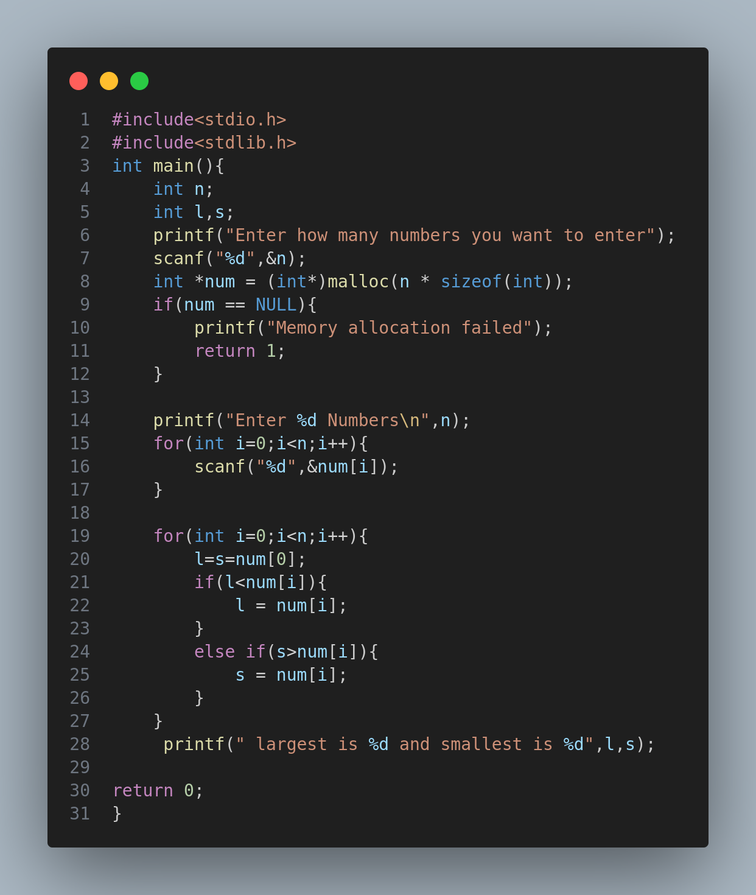
4. Write a Cprogram to write some text “Welcome BCA Students “ in test.txt
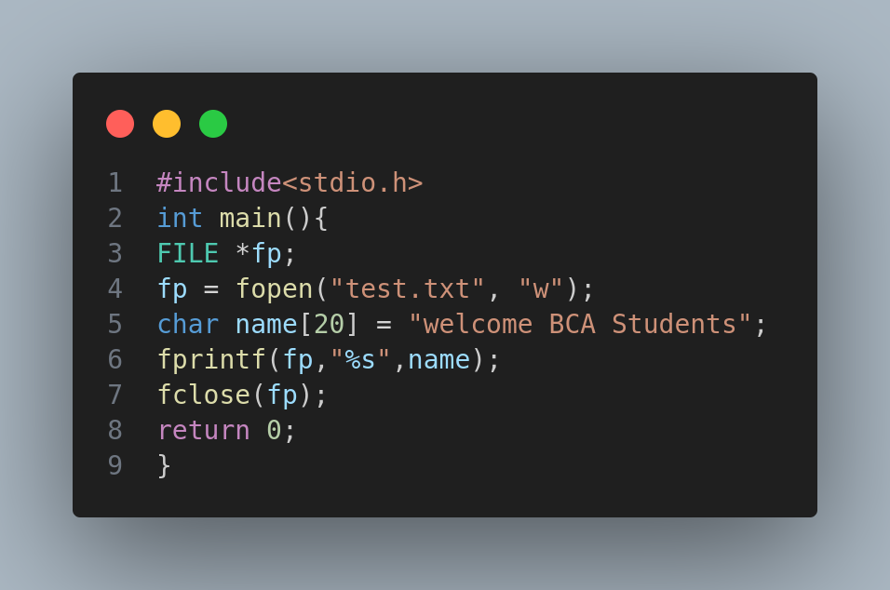

5.Explain any four graphics in C.
Ans: Graphics in C programming is used to create and manipulate images, shapes, and other graphical content on the screen. graphics.h header file provides graphical functions in c. There are many graphical function some of them are discussed below.

1. Line()
The line function is used to draw a straight line between two points in a graphical window.
Syntax: void line(int x1, int y1, int x2, int y2);
where,
x1, y1: Coordinates of the starting point
x2, y2: Coordinates of the ending point.

2. circle()
The circle function is used to draw a circle with a given center and radius.
Syntax:void circle(int x, int y, int radius);
where,
x, y: Coordinates of the circle's center.
radius: Radius of the circle.
3. rectangle
The rectangle function is used to draw a rectangle by specifying the coordinates of its top-left and bottom-right corners.
Syntax: void rectangle(int left, int top, int right, int bottom);
where,
left, top: Coordinates of the top-left corner.
right, bottom: Coordinates of the bottom-right corner.
4. setbkcolor()
This function changes the background of the screen to the specified color.
Syntax: void setbkcolor(int color);
Where,
color: The color code for the background. It can be one of the predefined colors available in the graphics.h library (e.g., BLACK, WHITE, RED, etc.).

GROUP C
6. What is one dimensional array?How is it initialized? WPA to find sum of two m x n matrices
Ans: A one-dimensional array is the simplest type of array that stores a collection of elements of the same data type in a linear structure.
It is initialized as data_type array_name[size];
